## horizontal line



BDS Assignment 01

DSECLZG522 | Group 141

**─**

Group 141 Members

Kumar Anurag - 2021FC04016

Das Shubhankar Jagannath Arpita - 2021FC04154

Amit Kumar - 2021FC04433

Siddhant Shivam - 2021FC04090

# DATASET USED

COVID-19 Kaggle Dataset

We have used the given dataset from the provided Kaggle [link](https://www.kaggle.com/datasets/imdevskp/corona-virus-report?select=country_wise_latest.csv).

# OUTCOMES

1. The number of new cases, new deaths and new recovered

Showing all Available Databases:

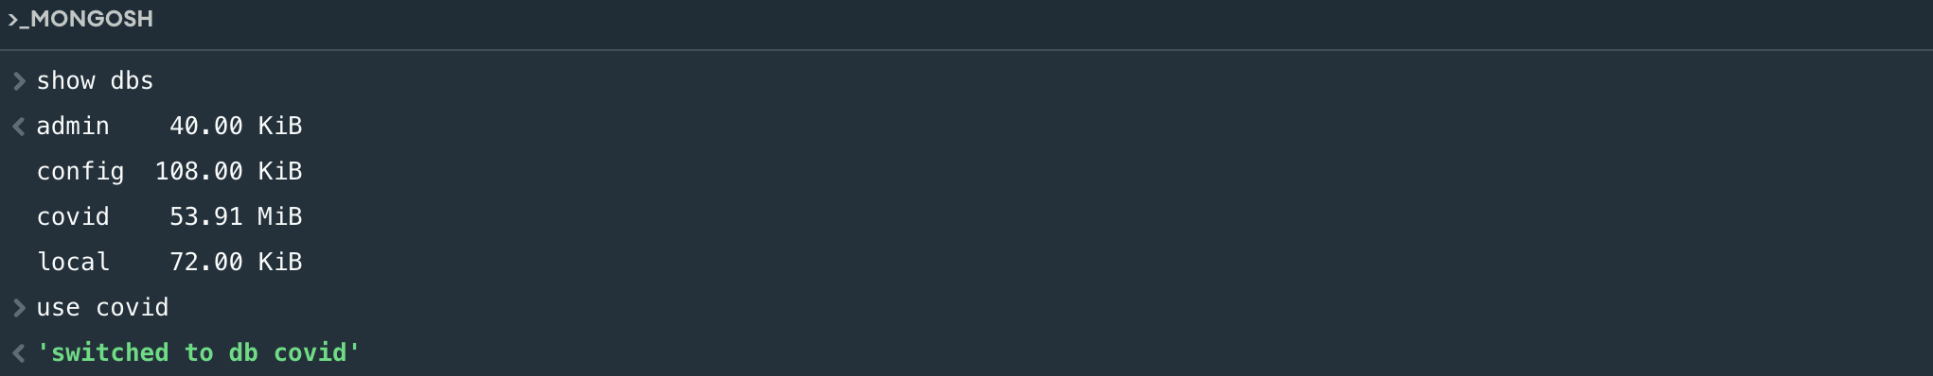

Number of new cases, new deaths and new recovered:

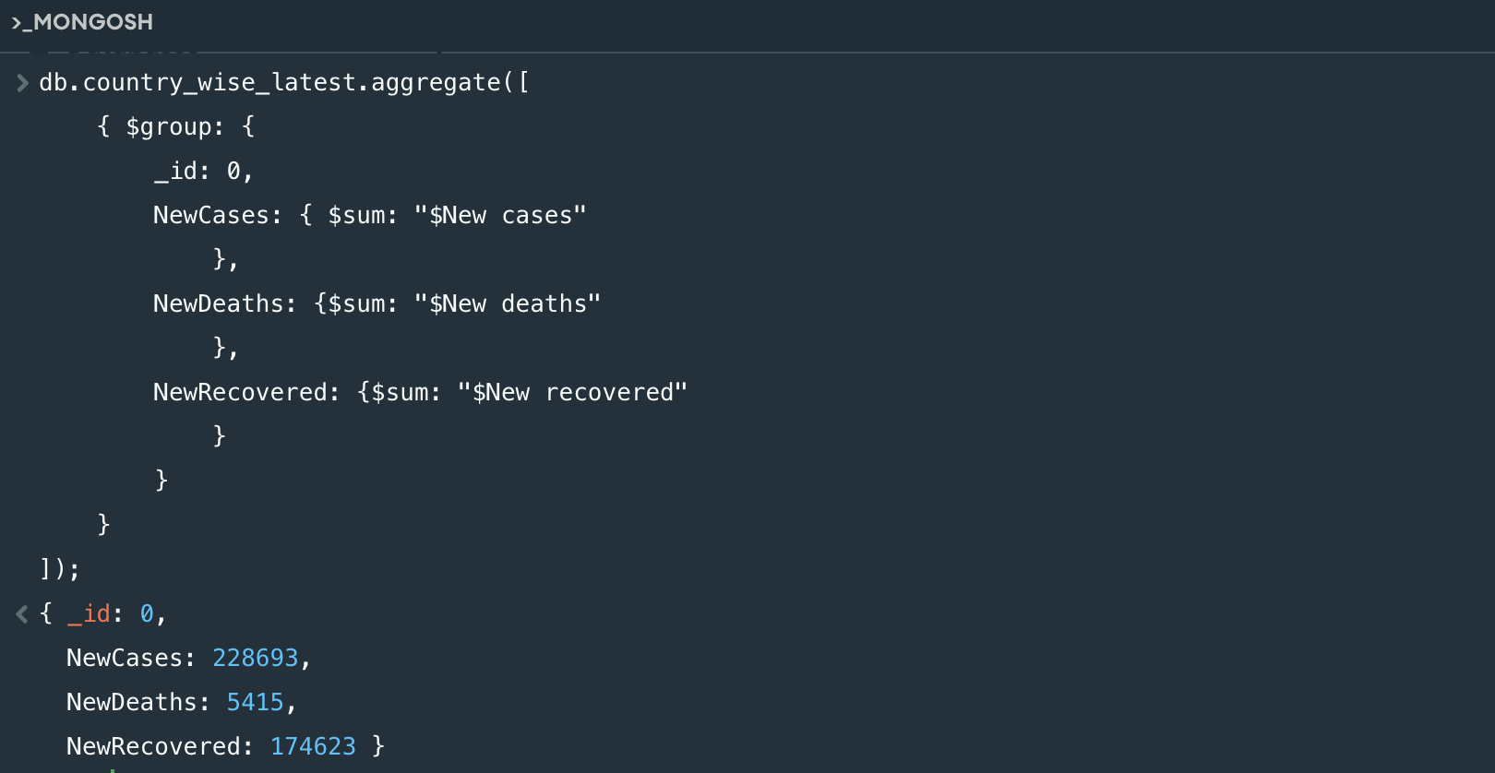

1. The number of death cases in each country of continent Asia and also the corresponding WHO regions

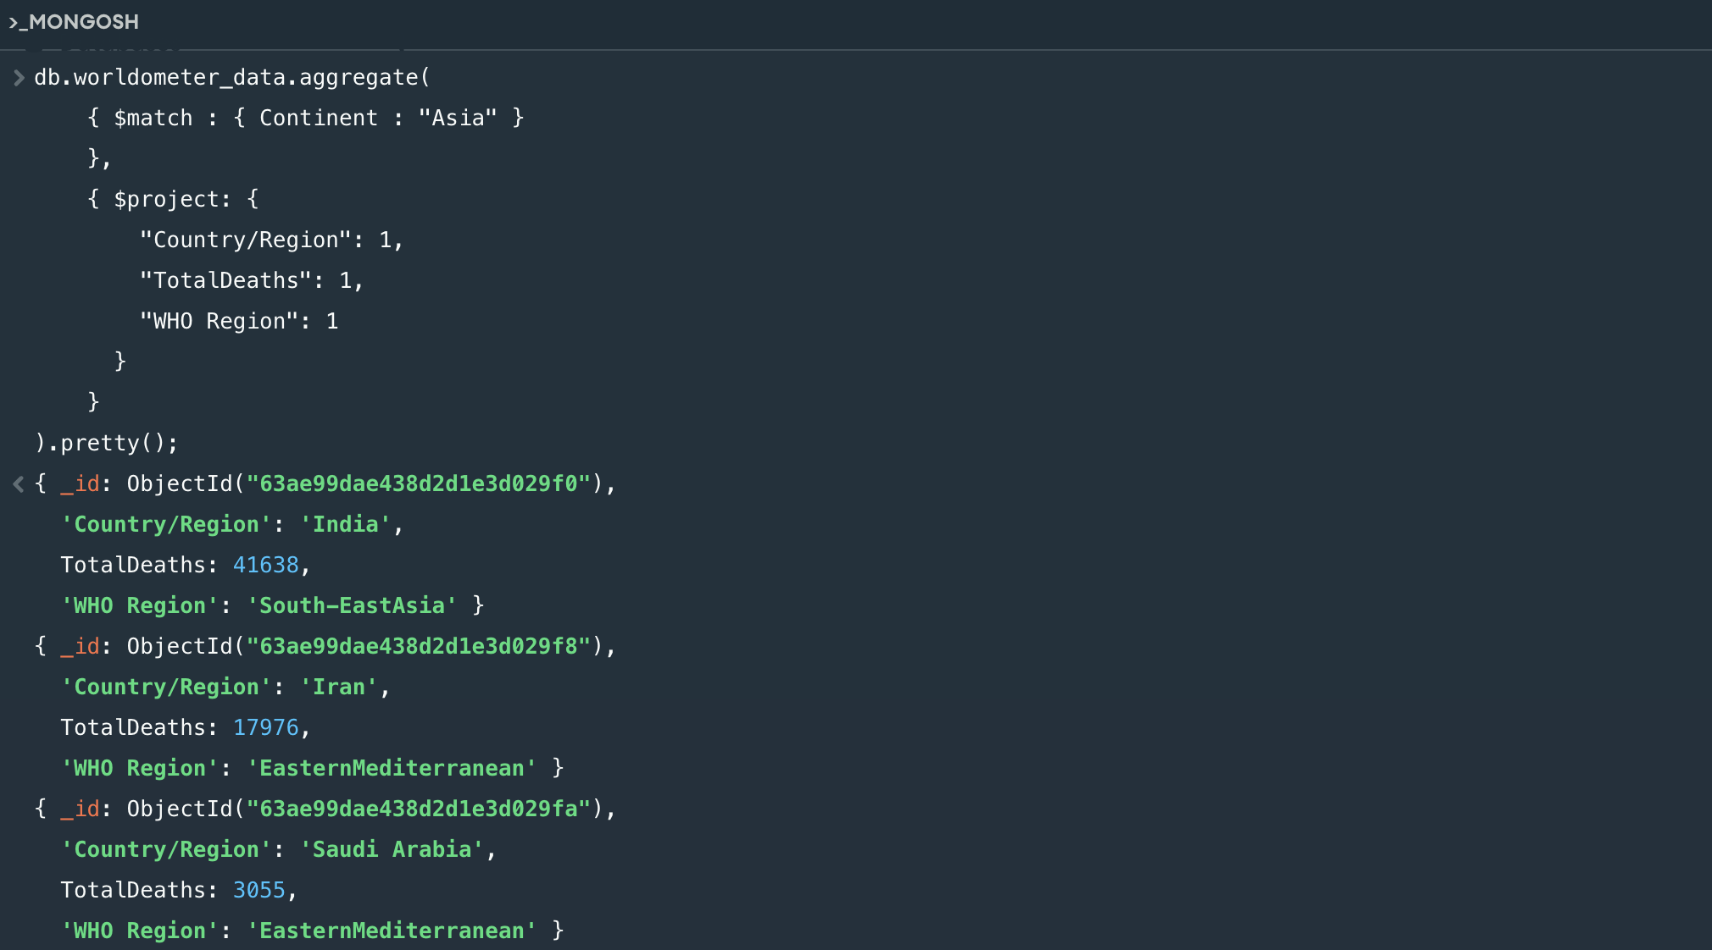

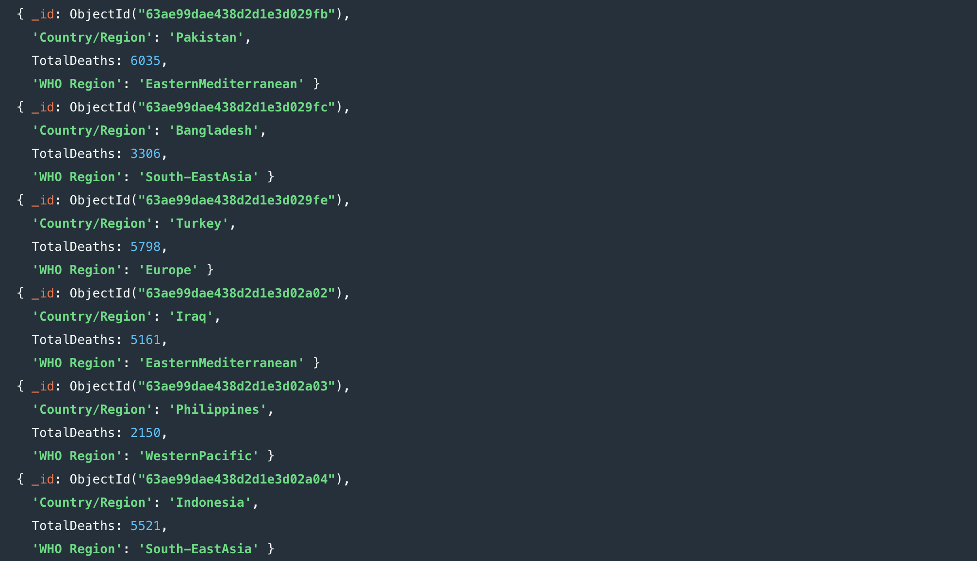

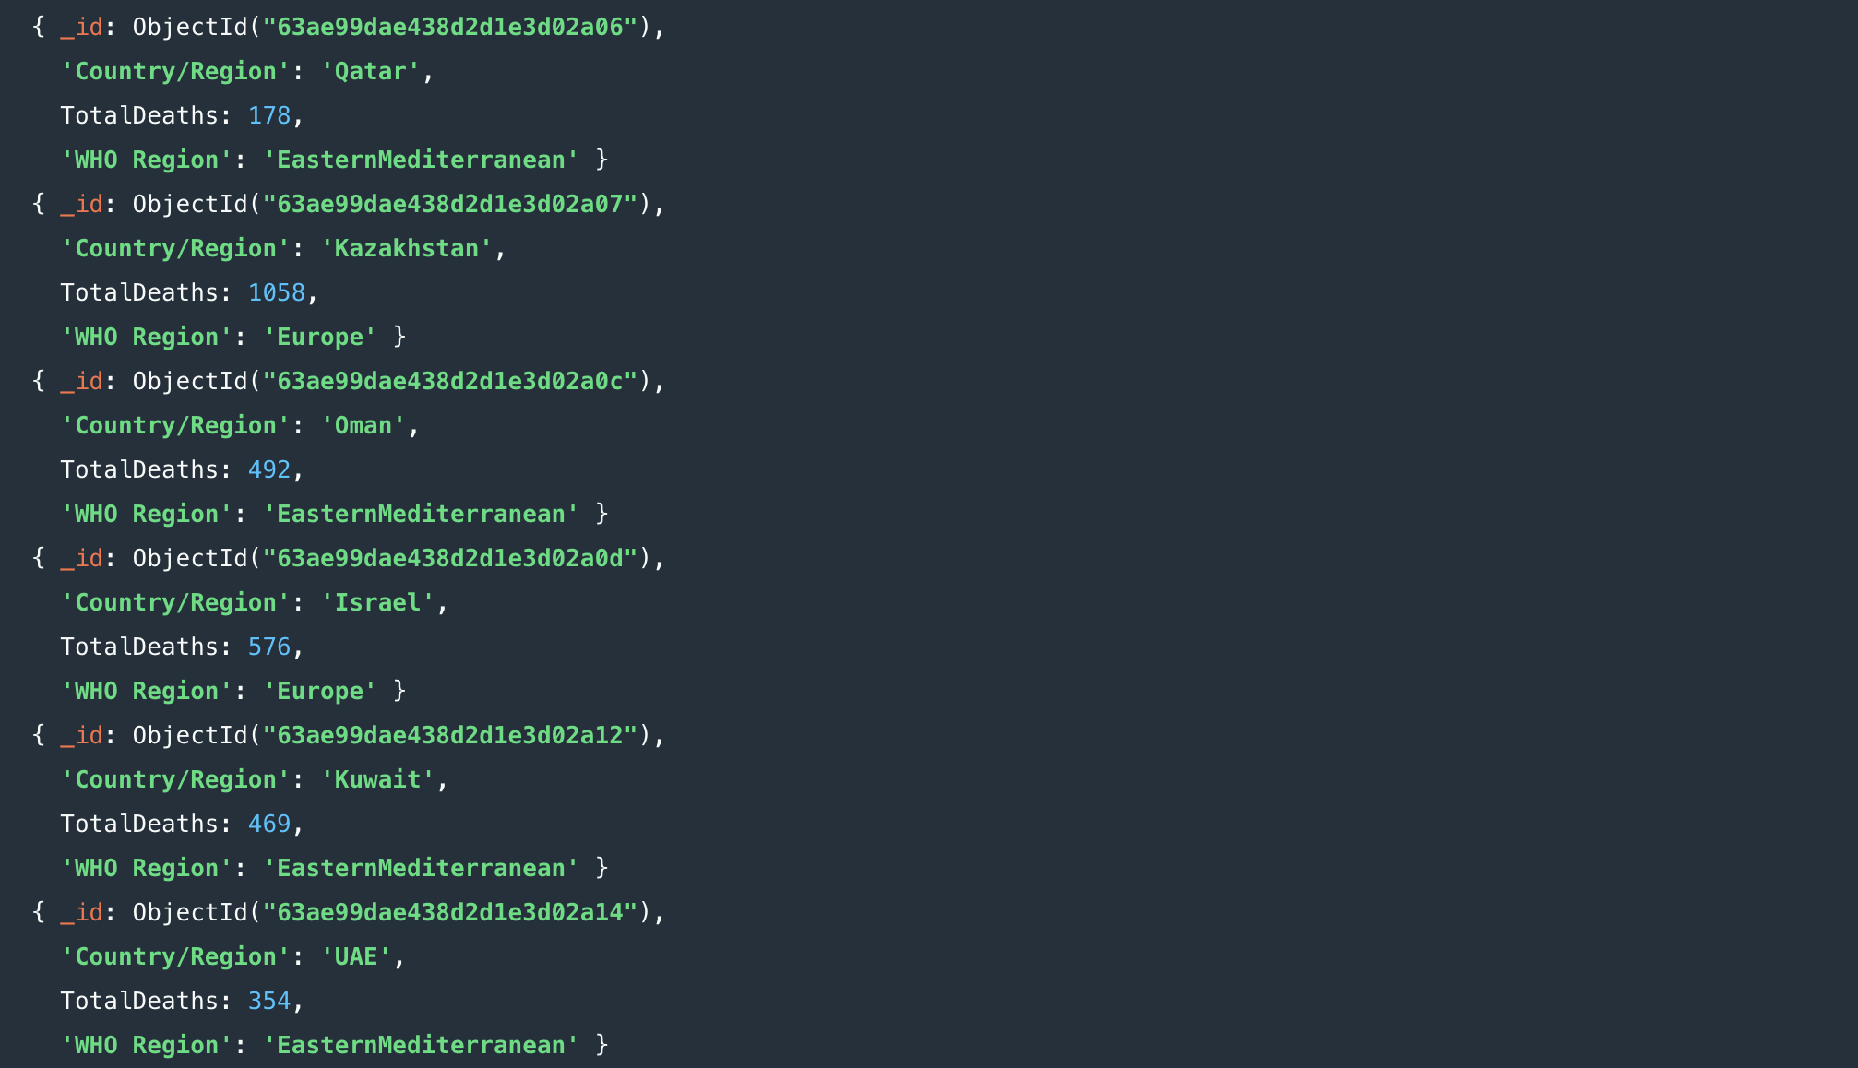

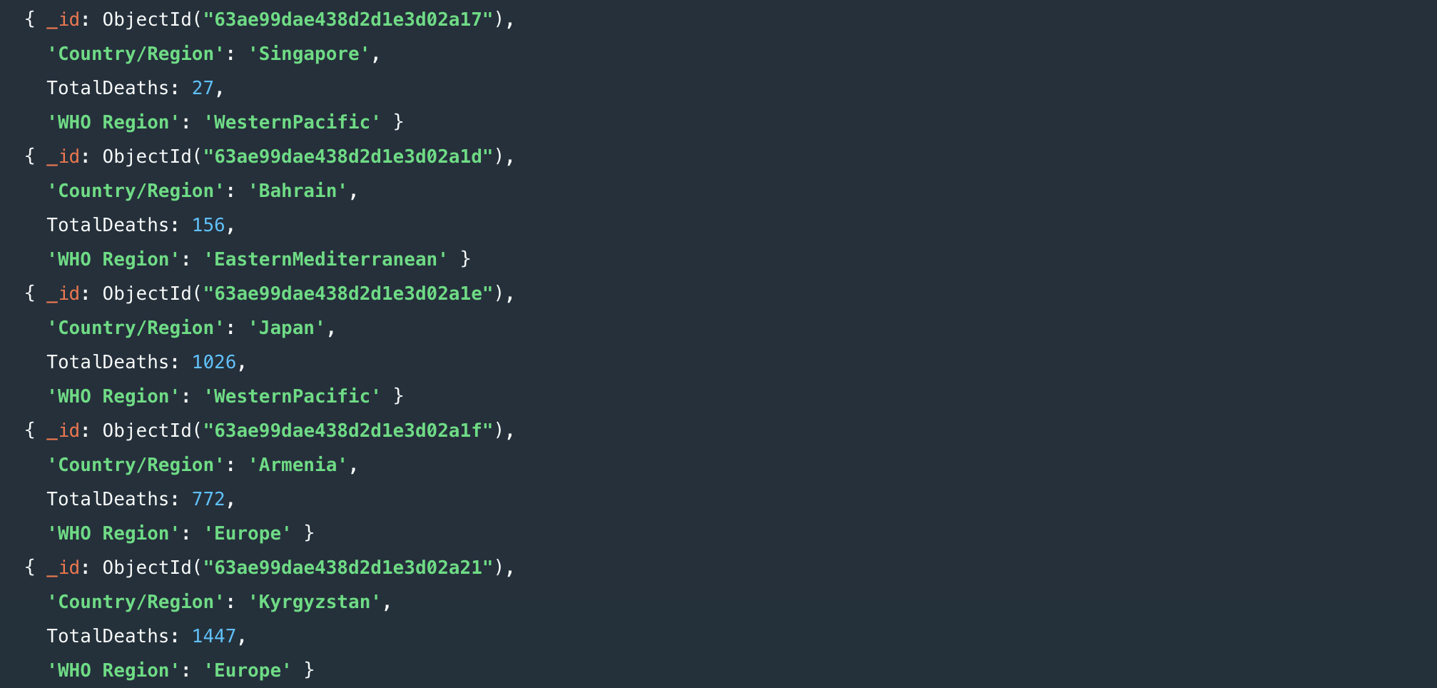

1. The number of deaths that occurred on 12-02-2020

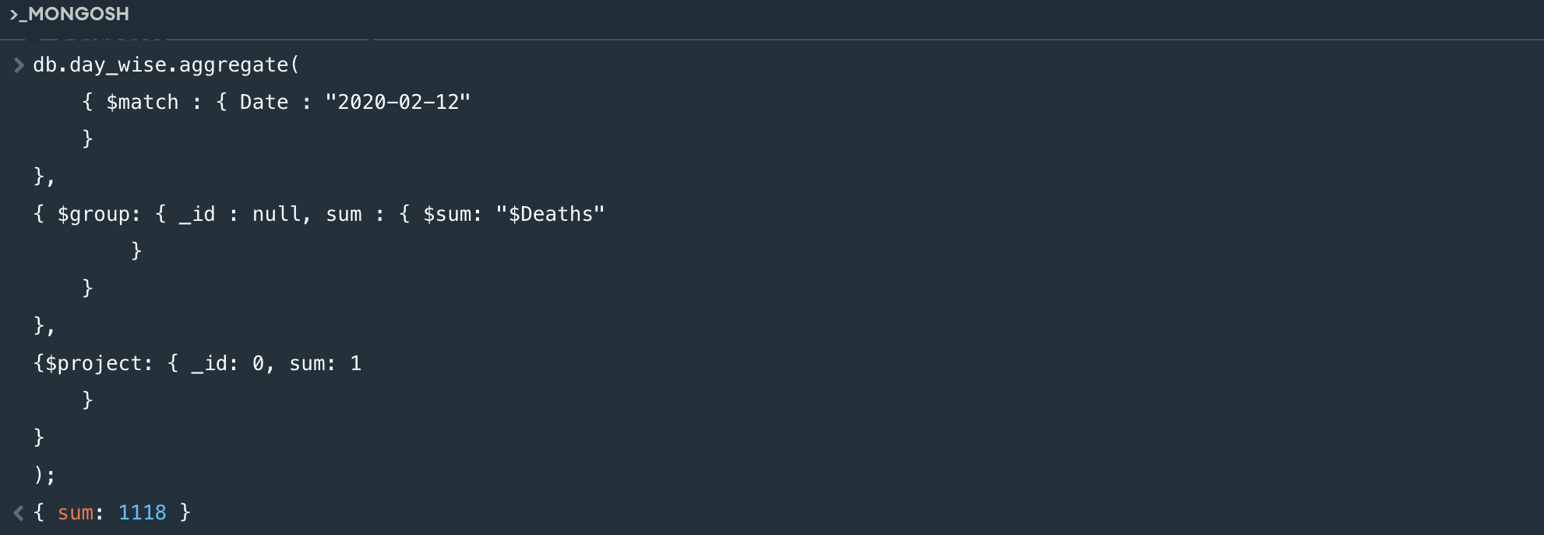

1. The number of active new cases (new cases-(new death+new recovered)) in a reverse sorted order based on the country name

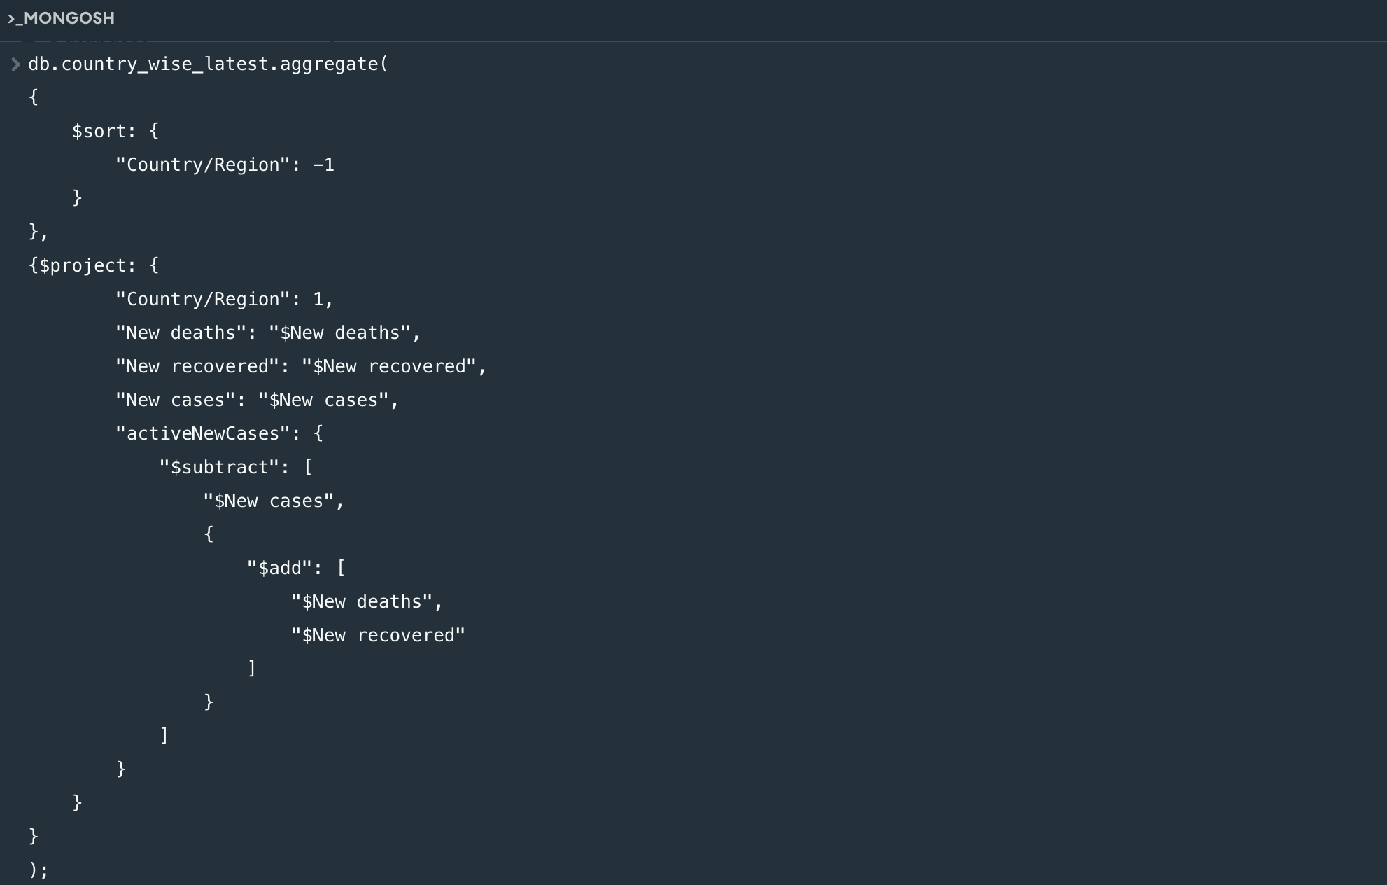

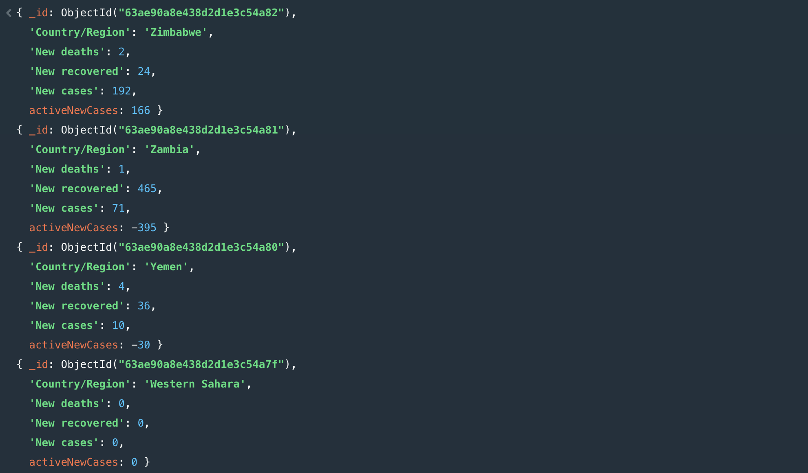

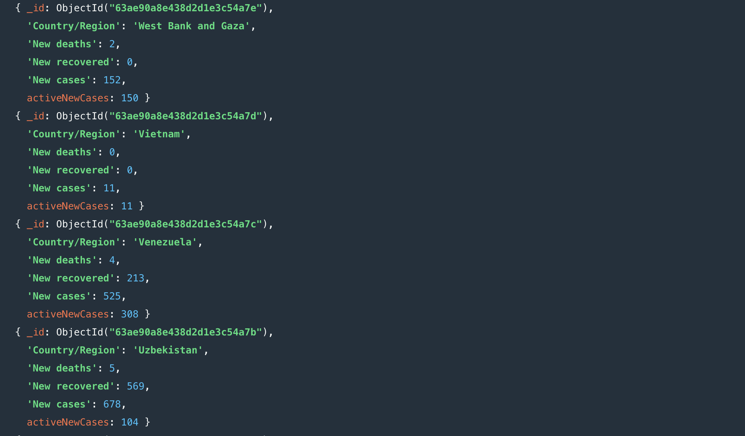

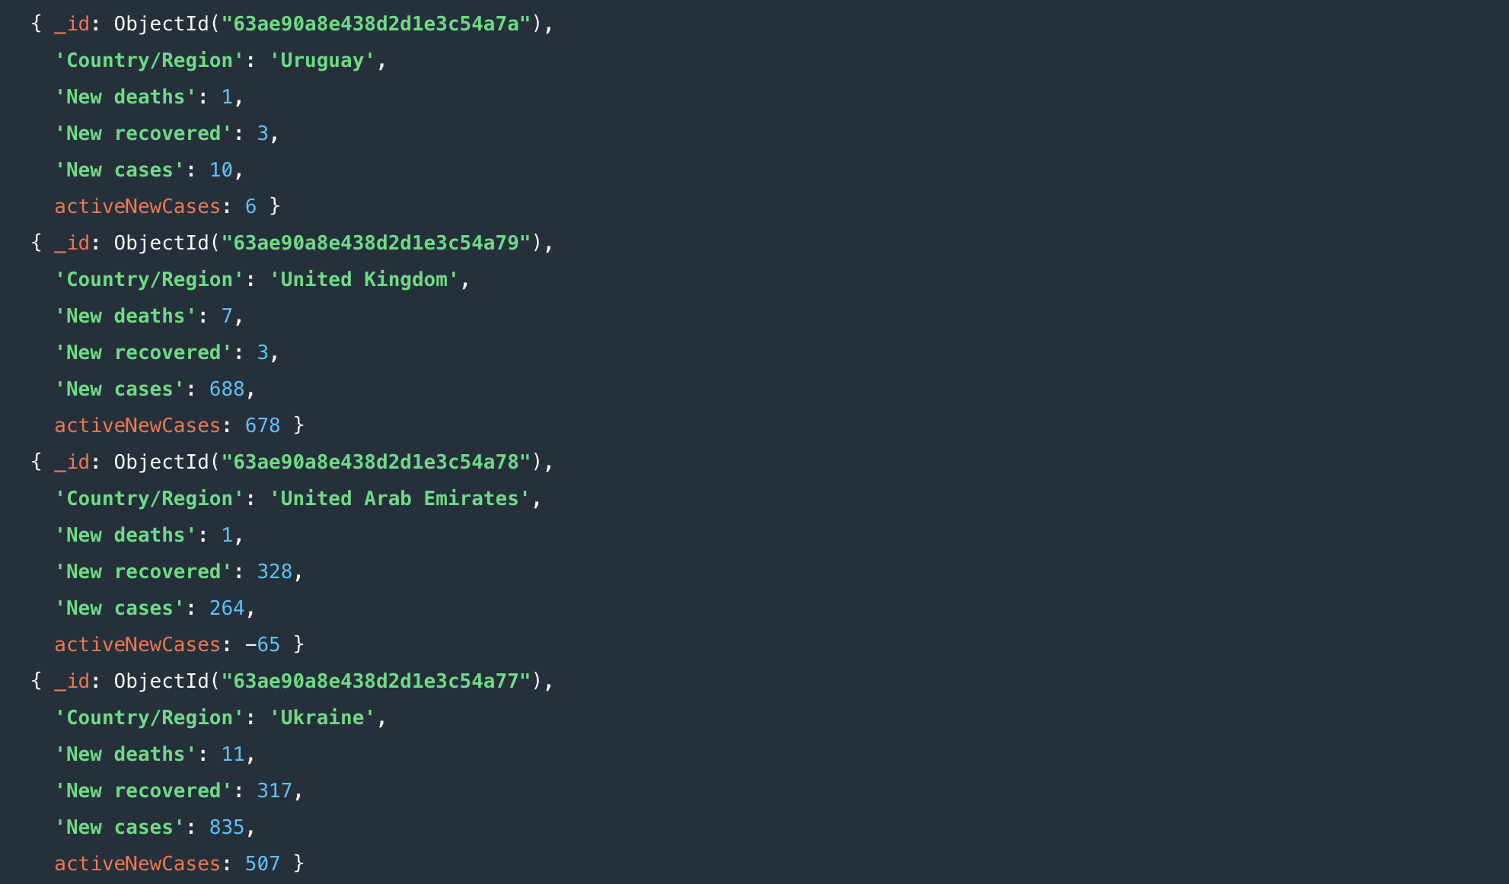

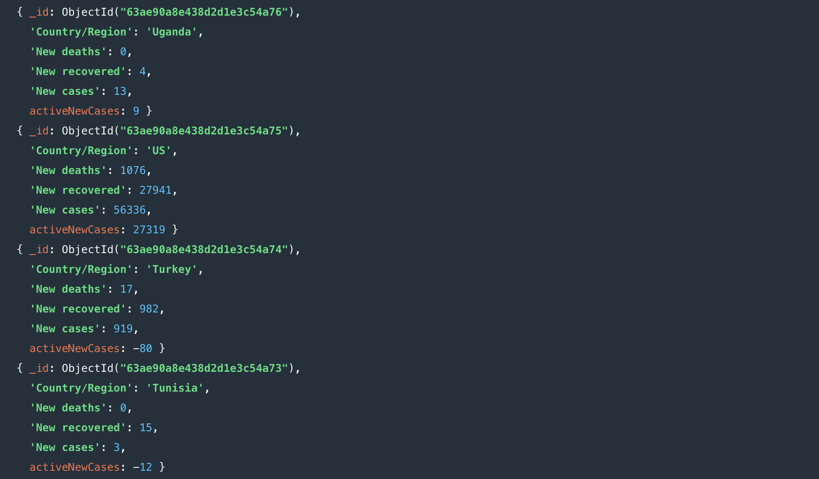

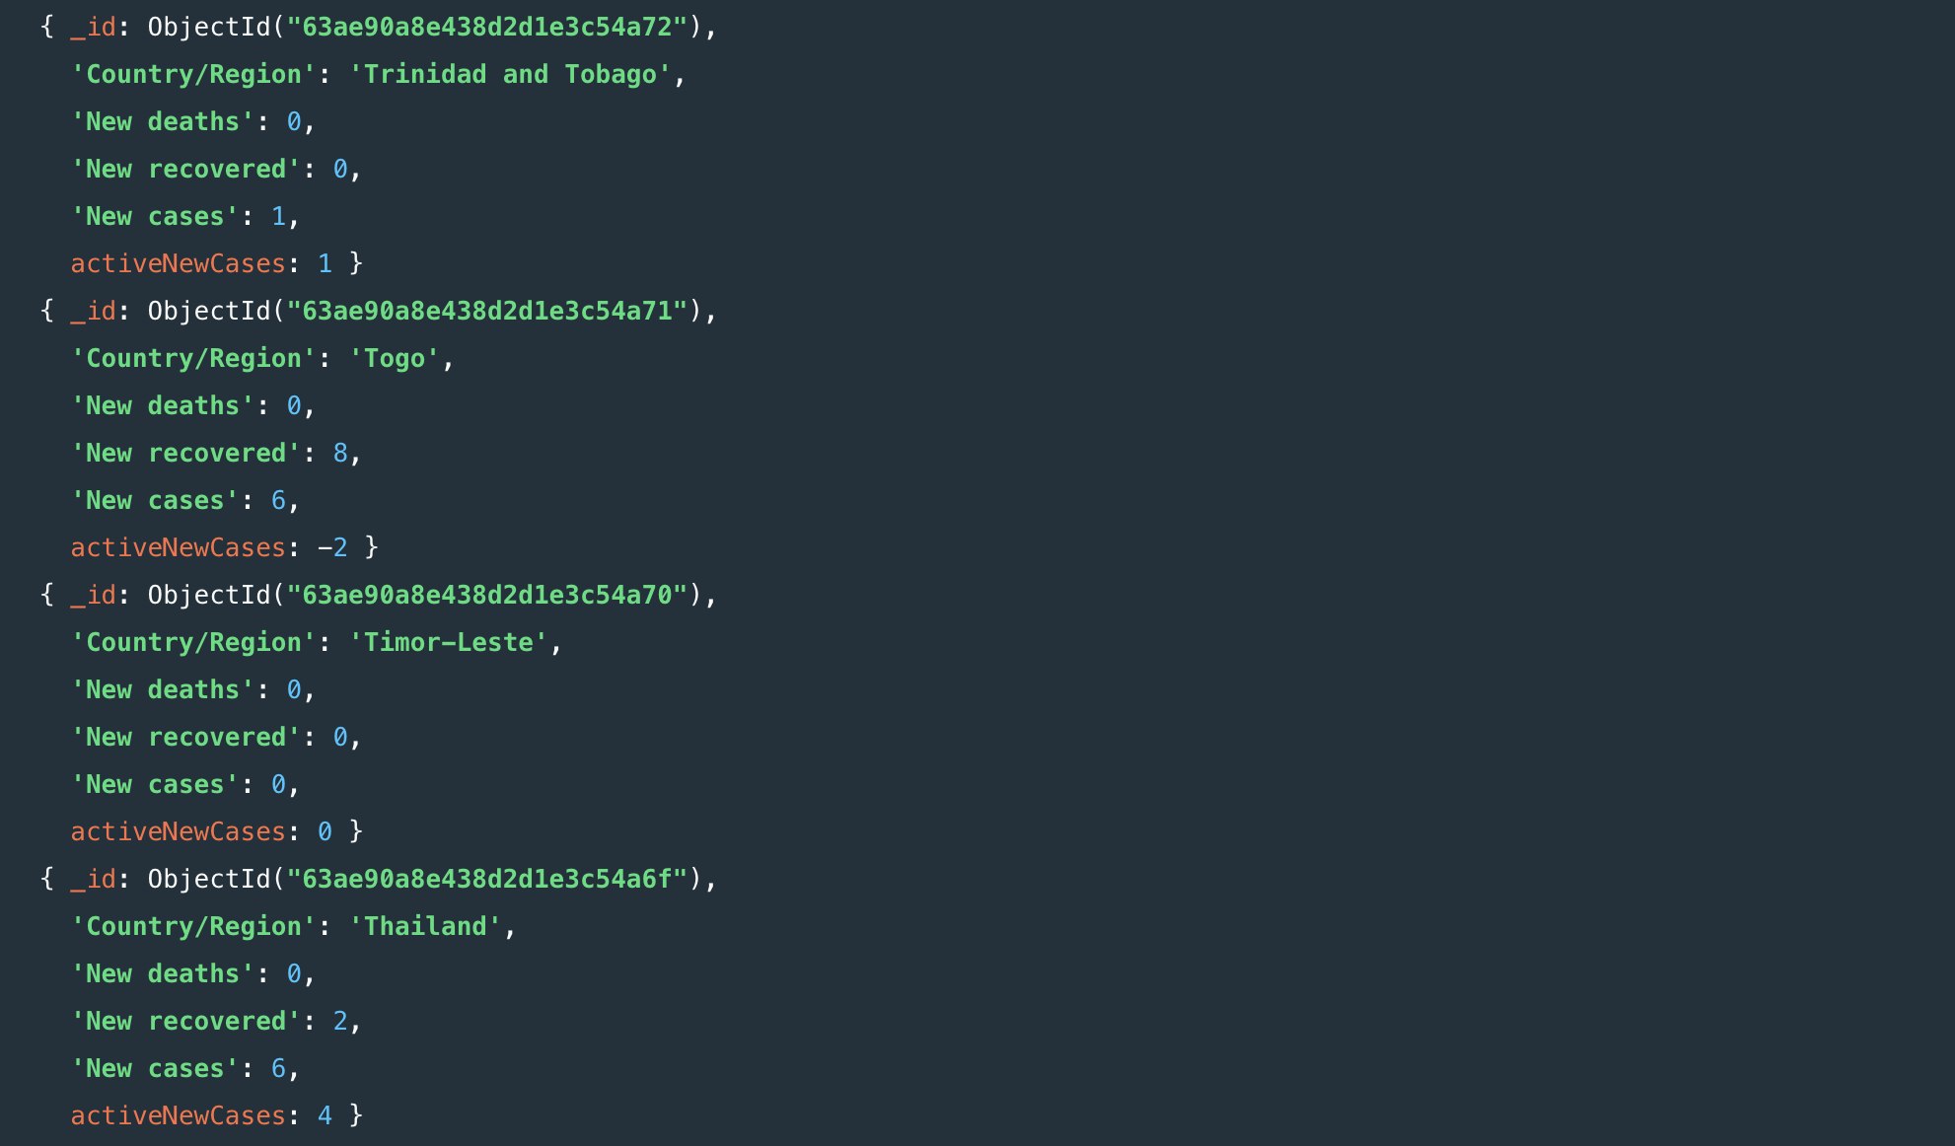

1. The names of the countries with more than 9000 active cases and more than 800 deaths

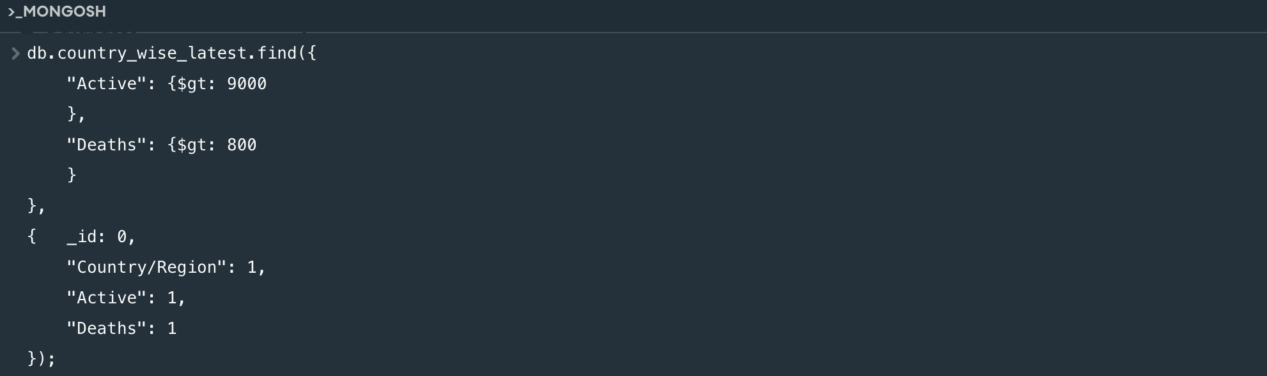

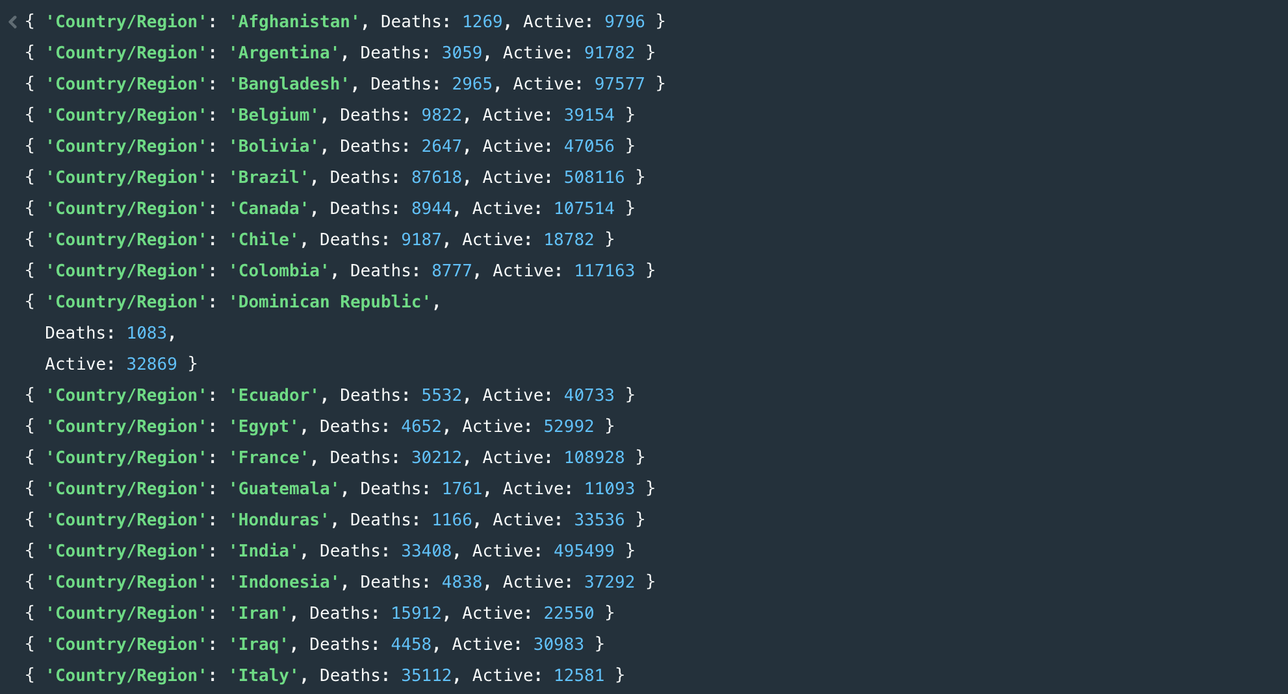

1. The country with the highest number of active cases and also with second highest death rate

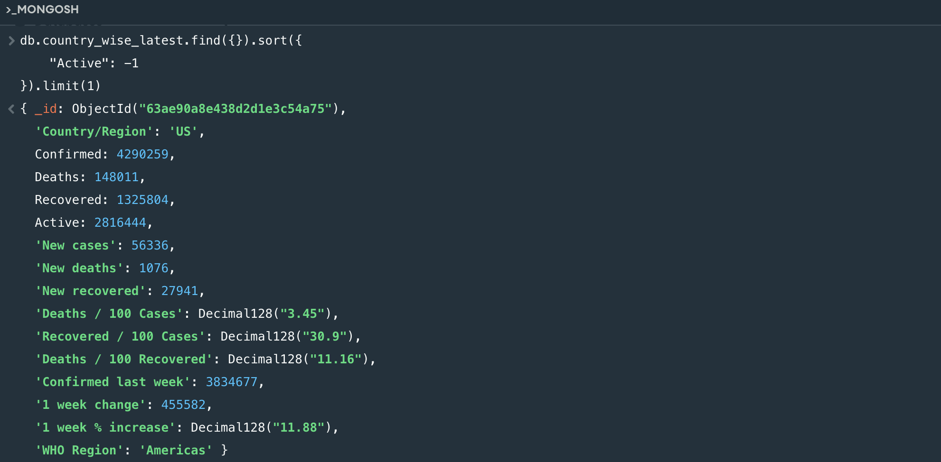

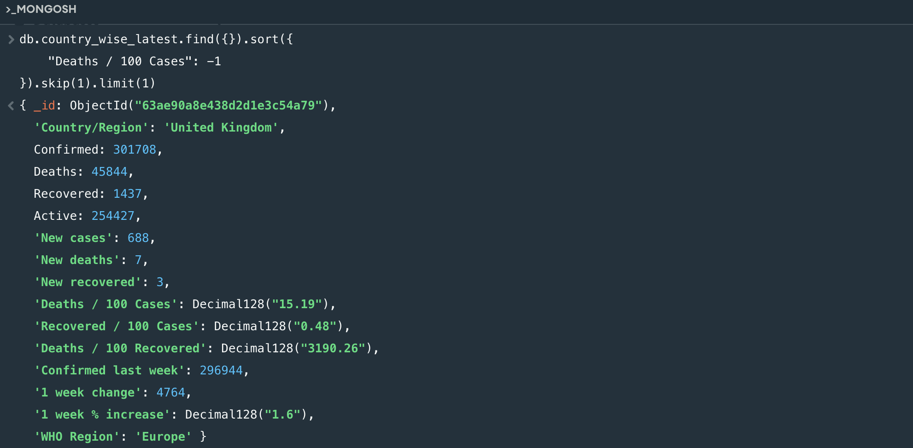

1. The total number of deaths all around the world

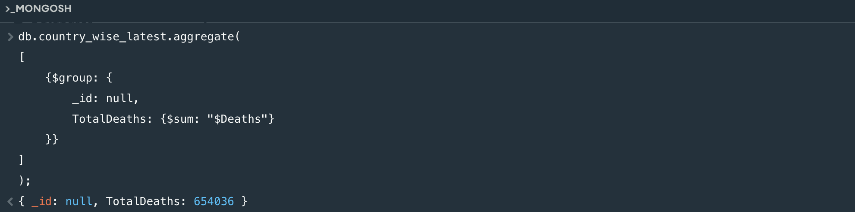

1. The number of death cases and active cases between 28-01-2020 and 21-02-2020

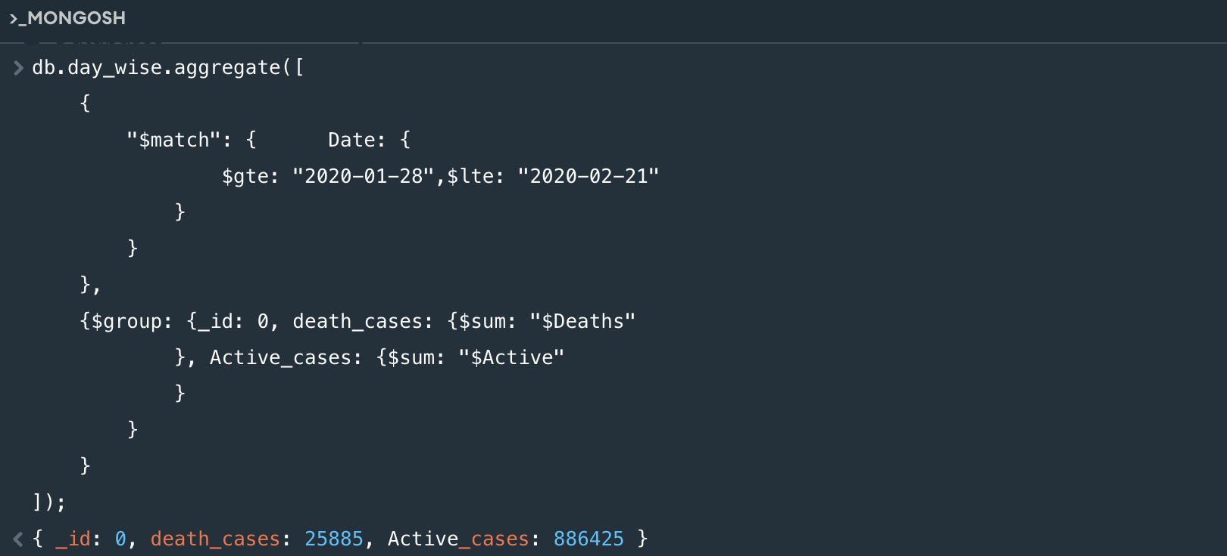

1. The latitude and longitude of countries ending with “ia” and the number of countries

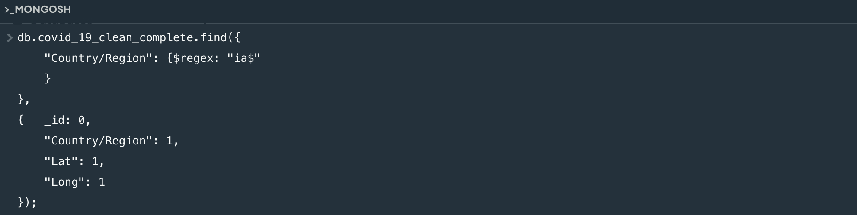

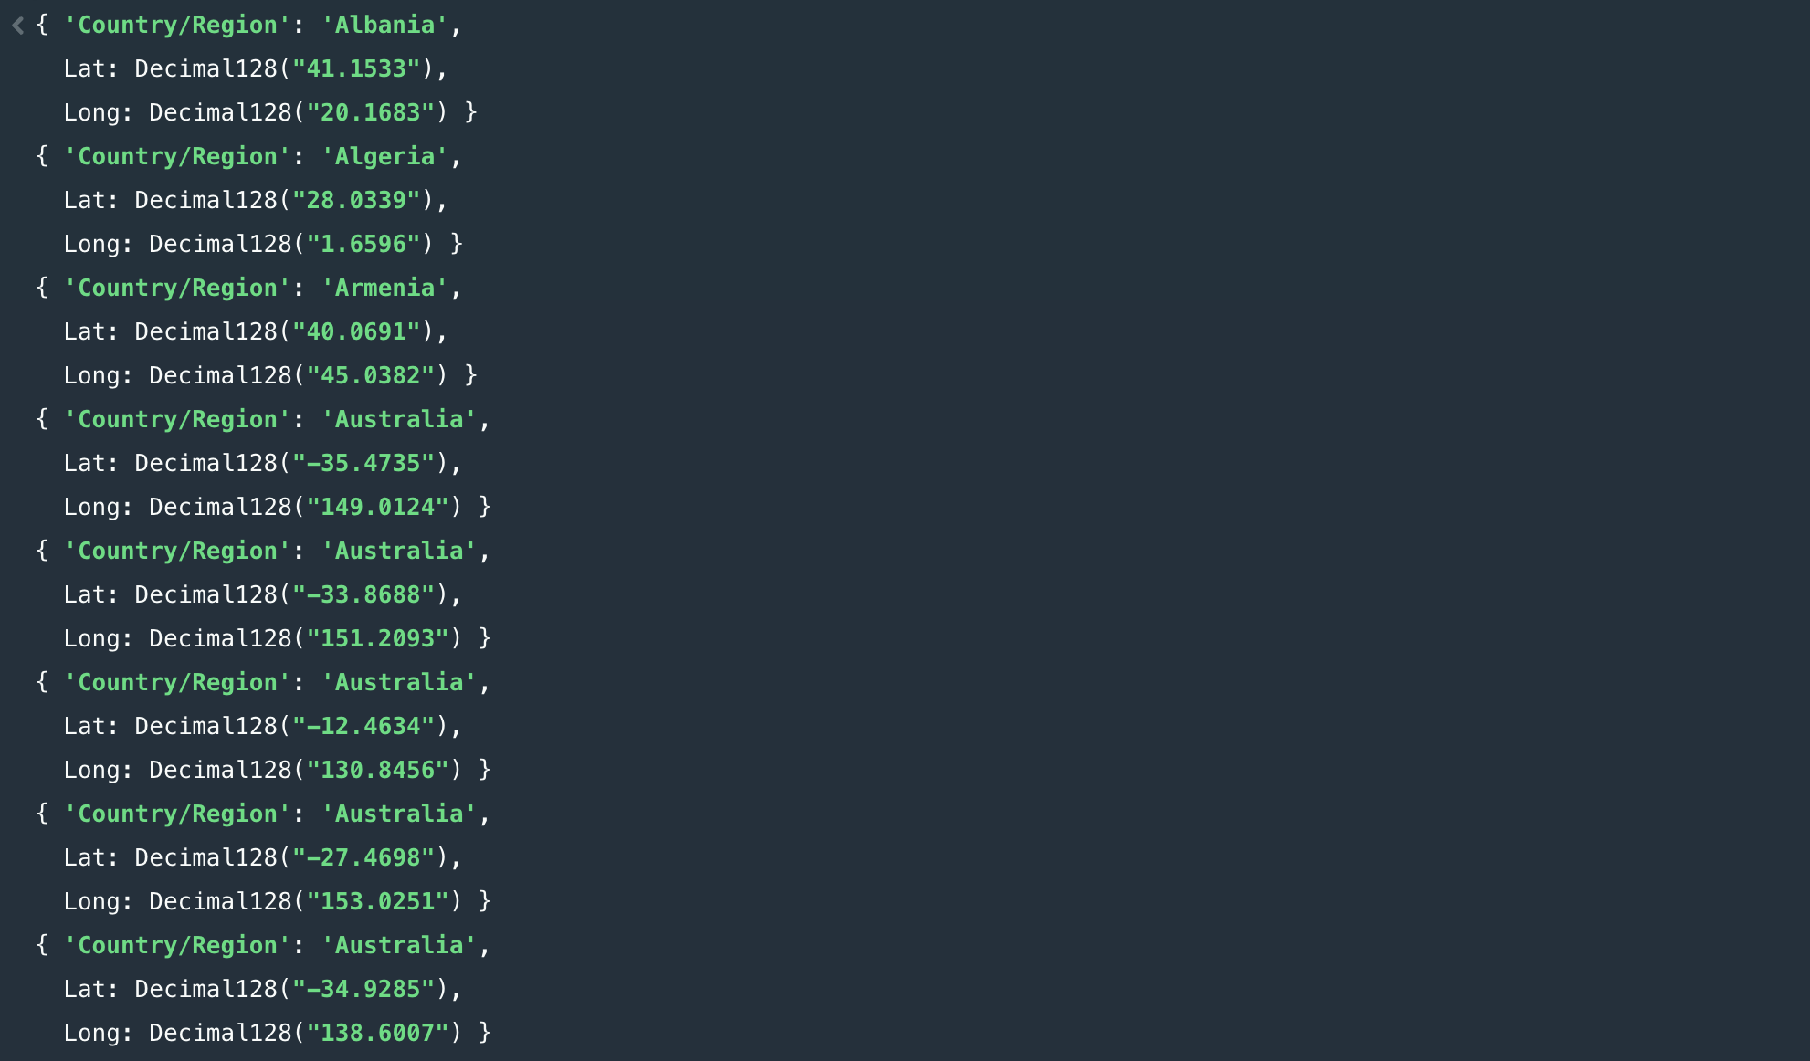

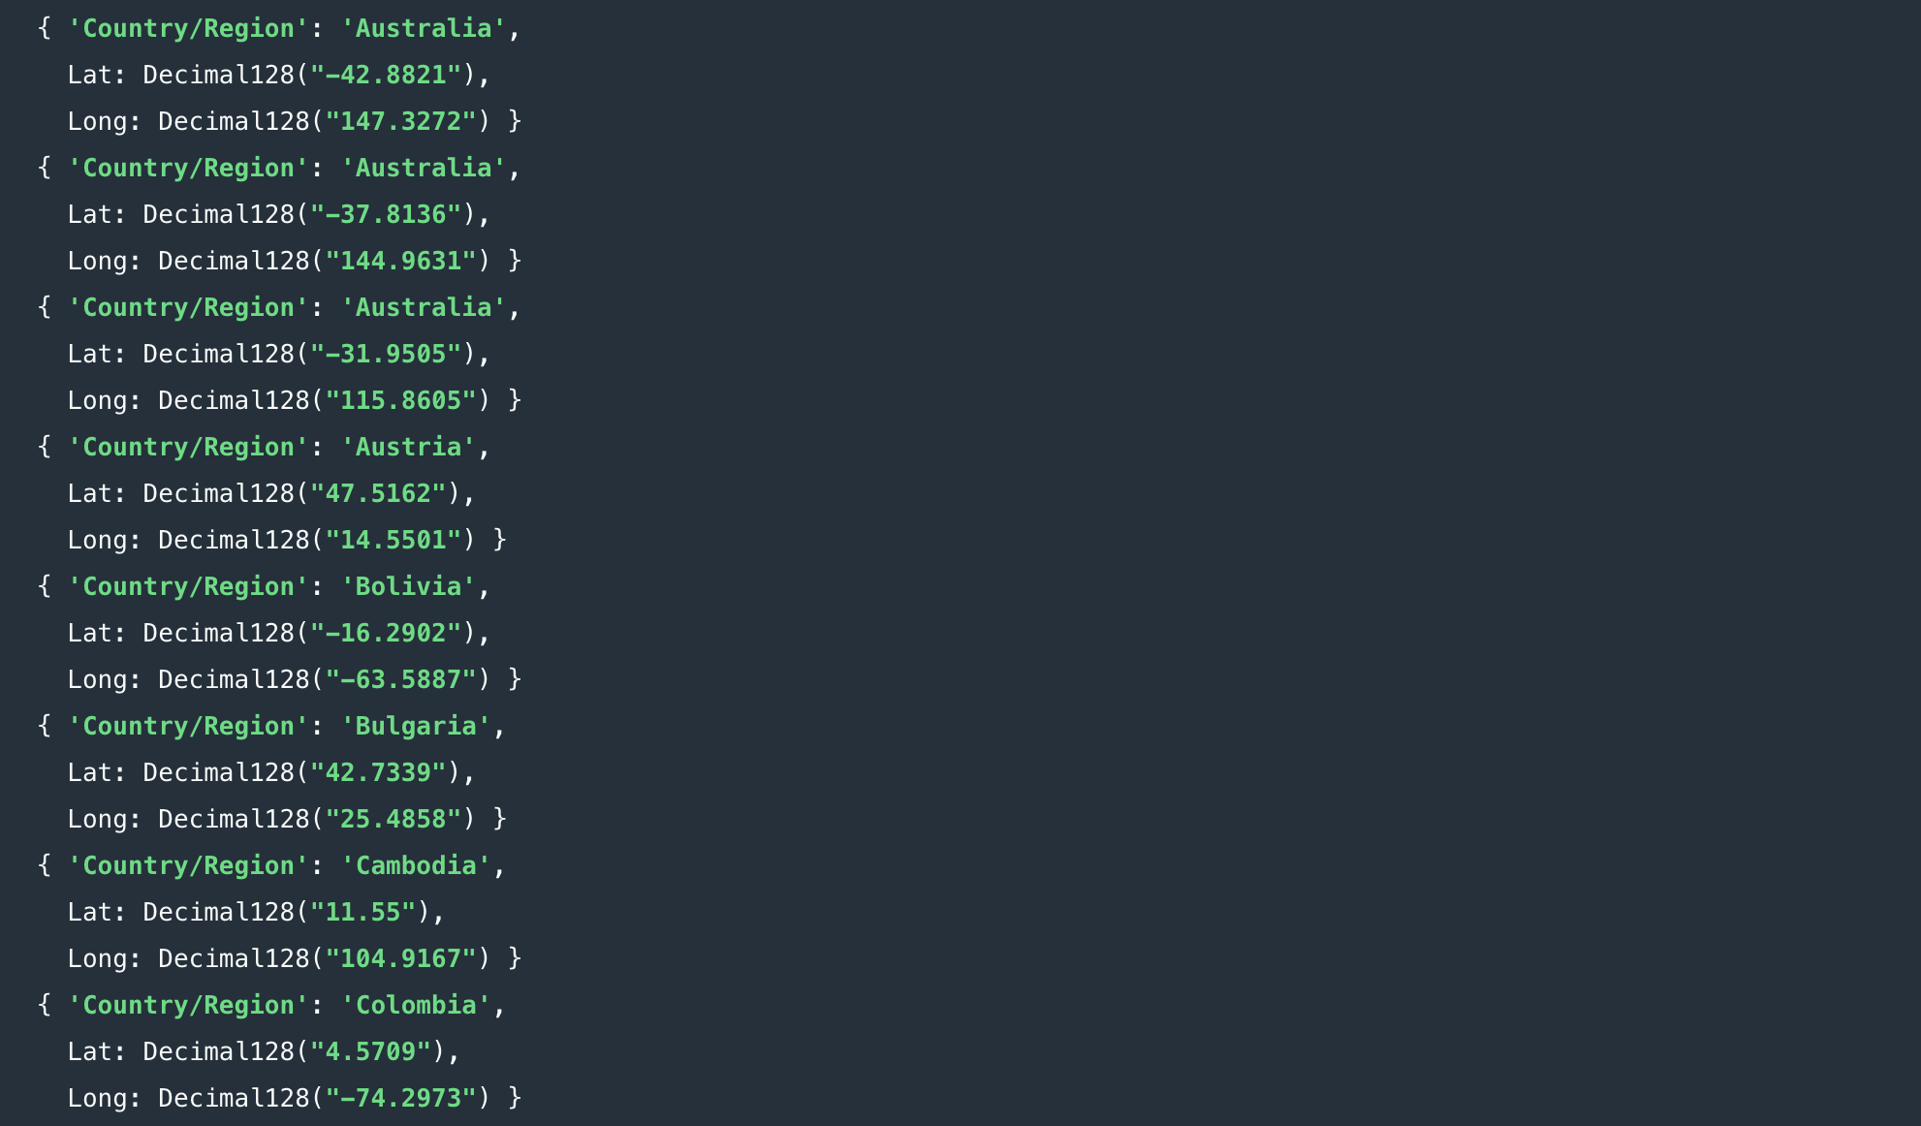

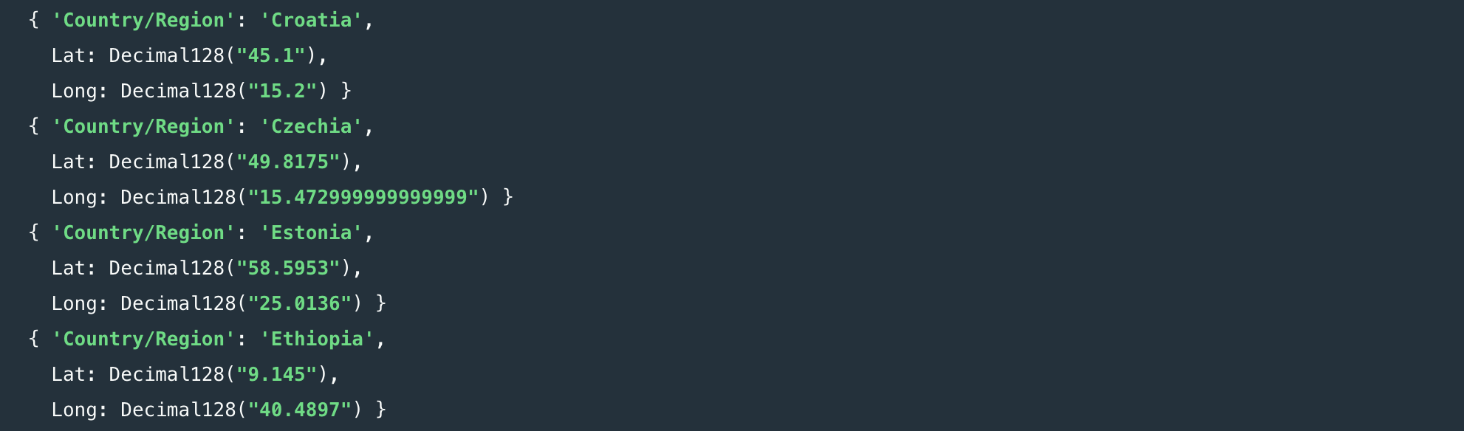

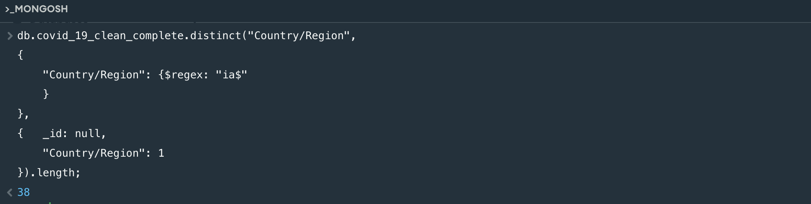

1. The countries with active cases on 30/03/2020

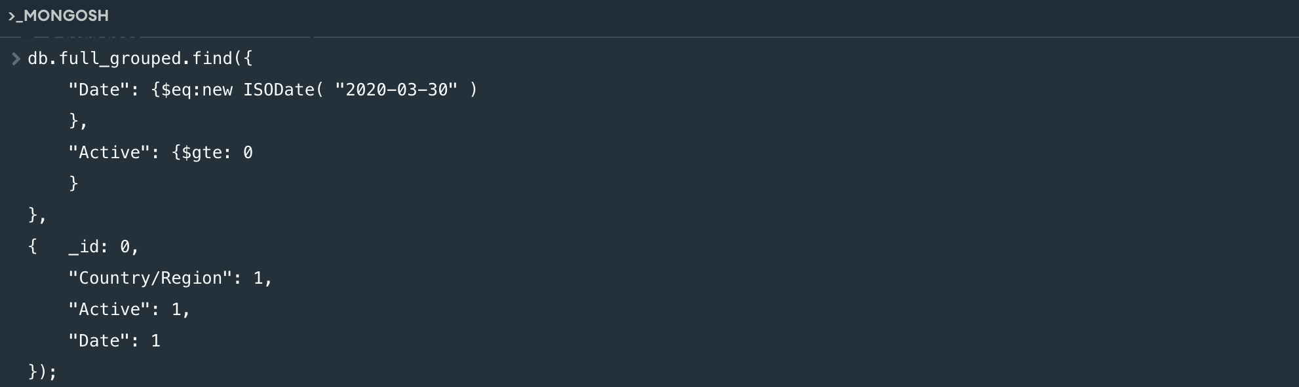

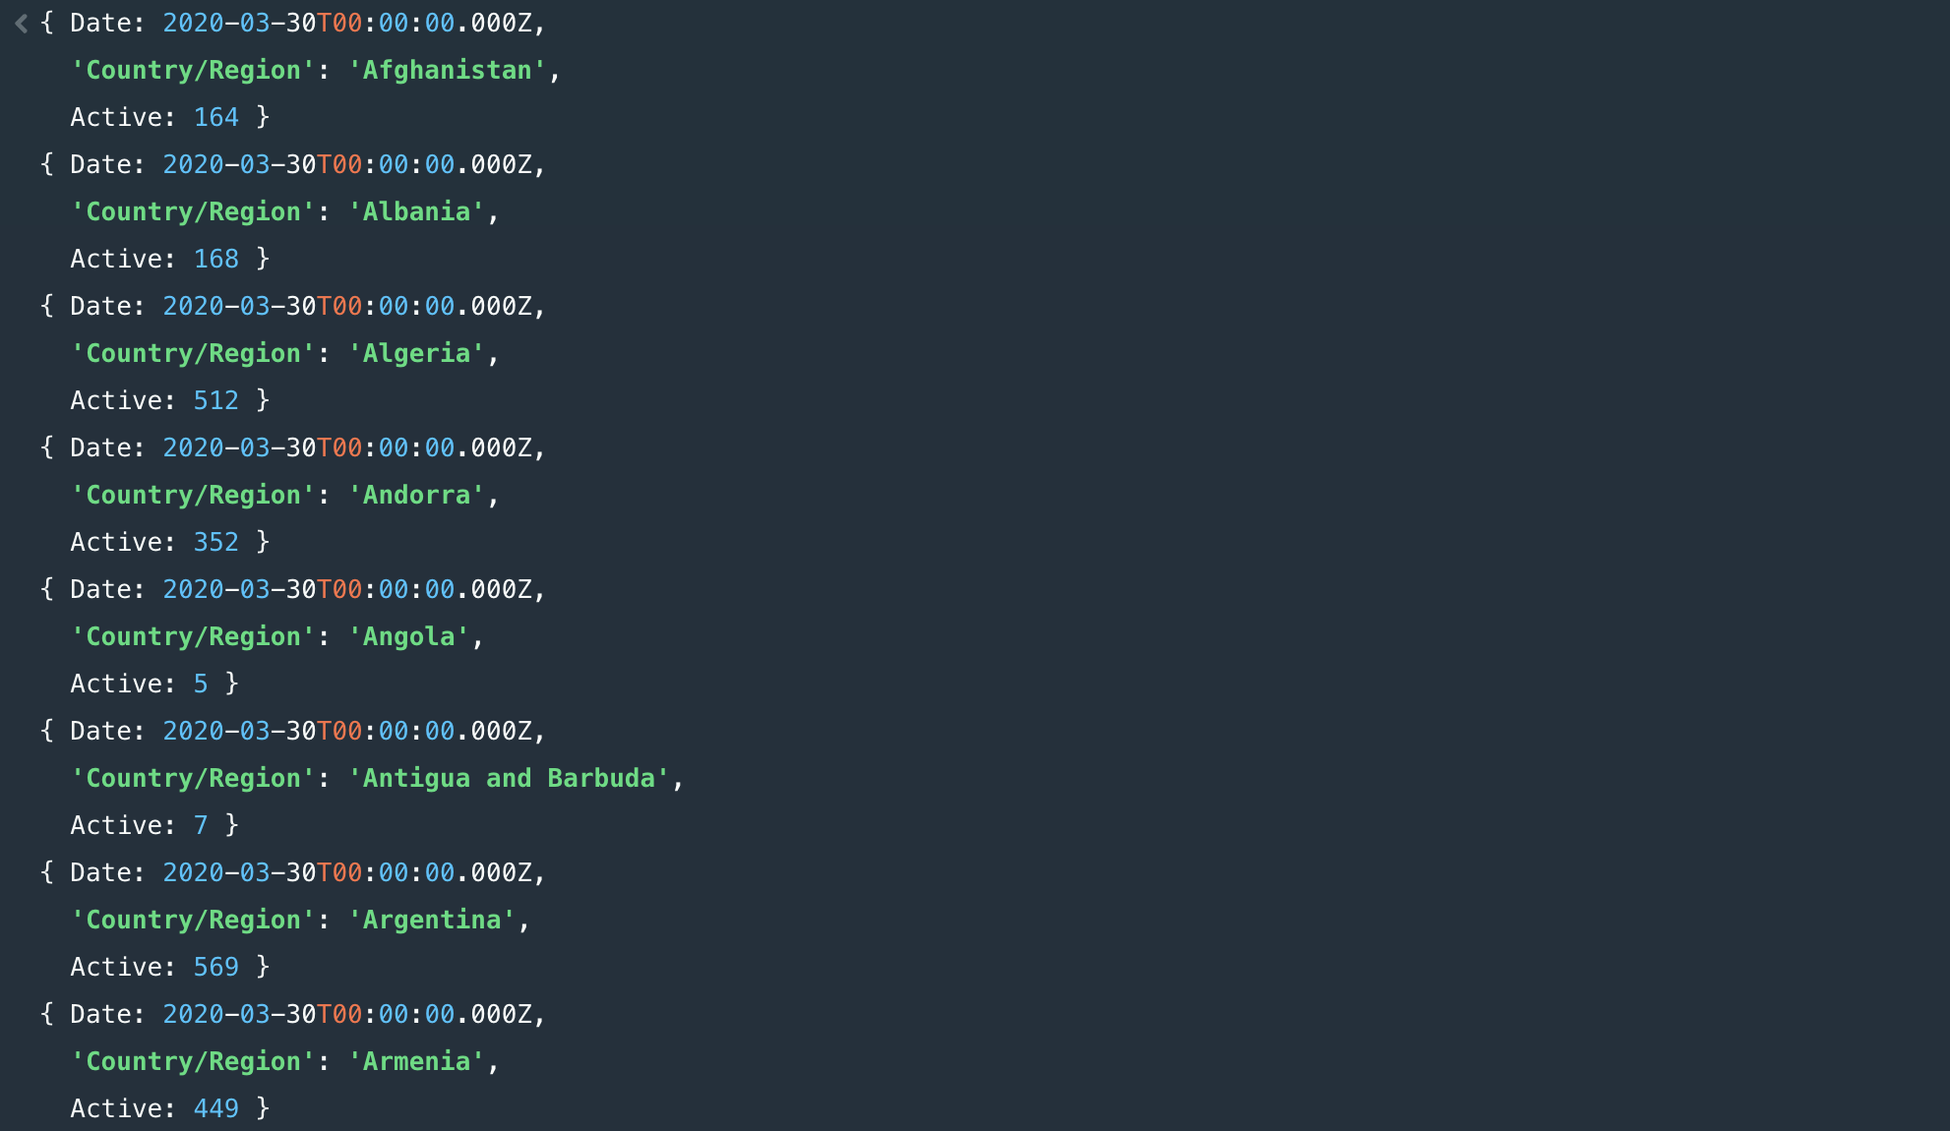

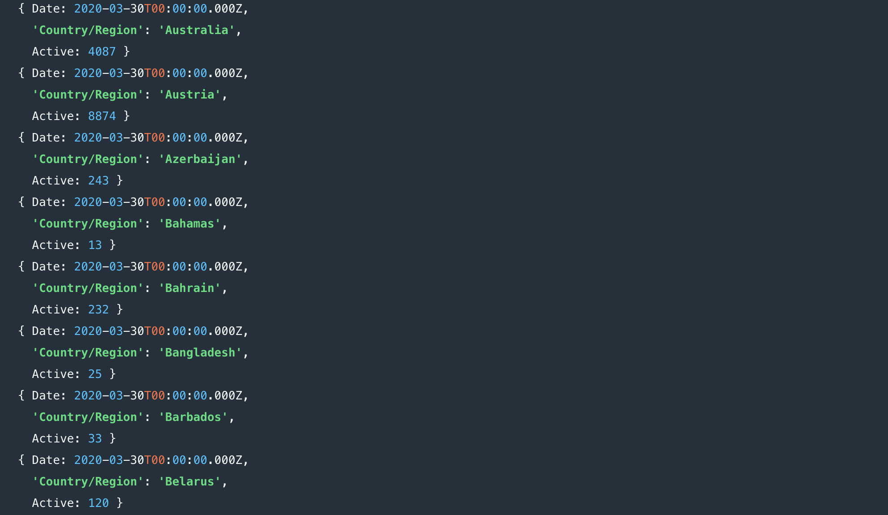

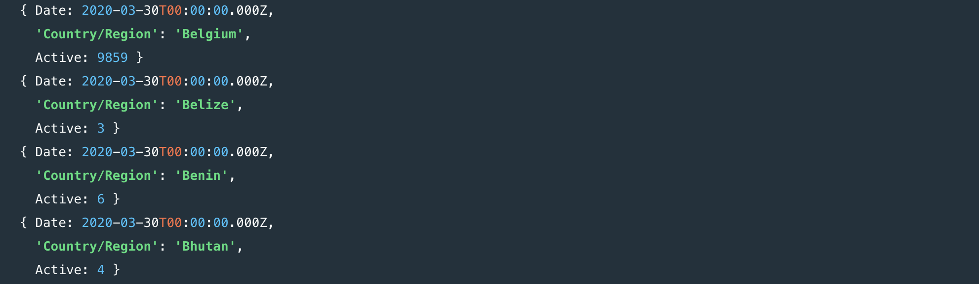

1. The latitude and longitude of those countries which are having active cases greater than 100

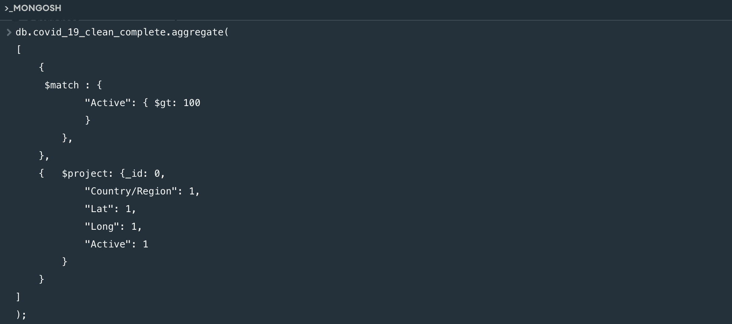

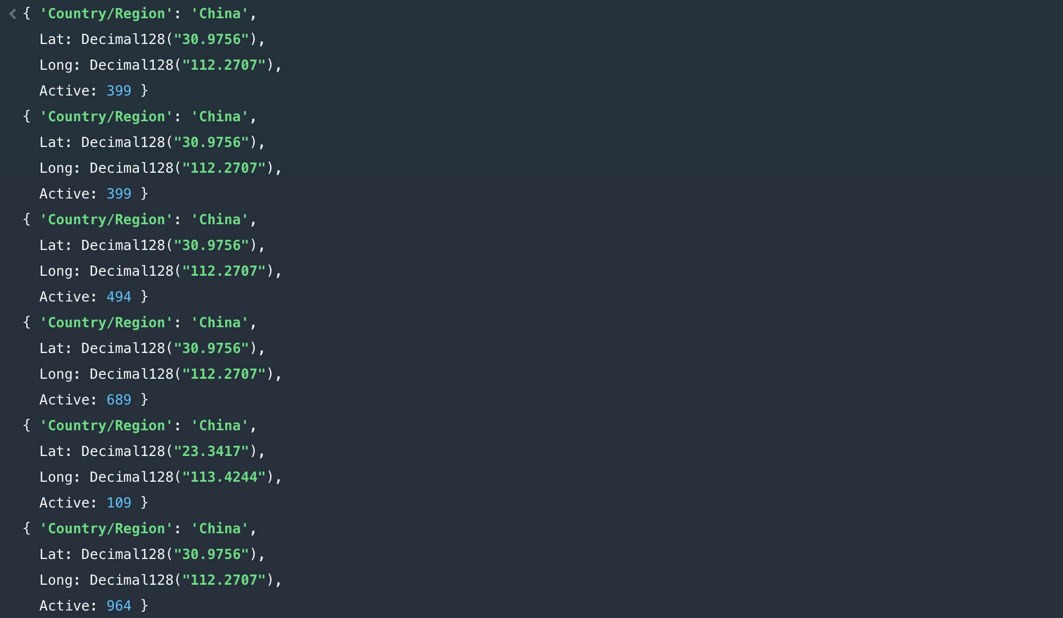

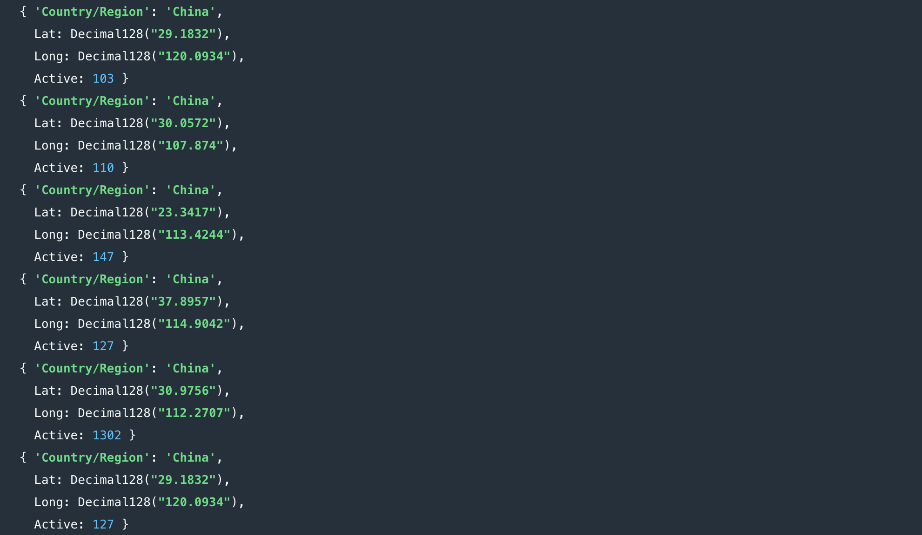

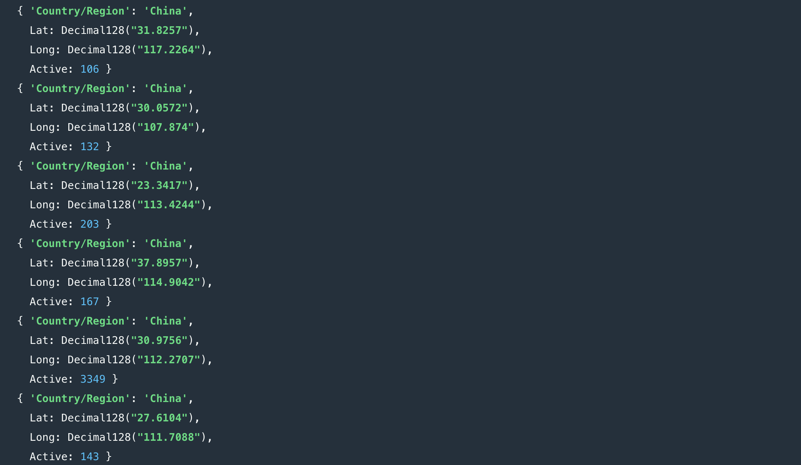

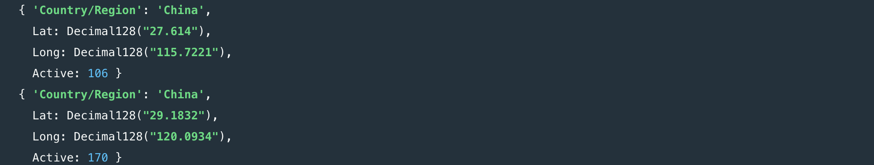

1. The countries and respective dates in which maximum increase of active cases occurred

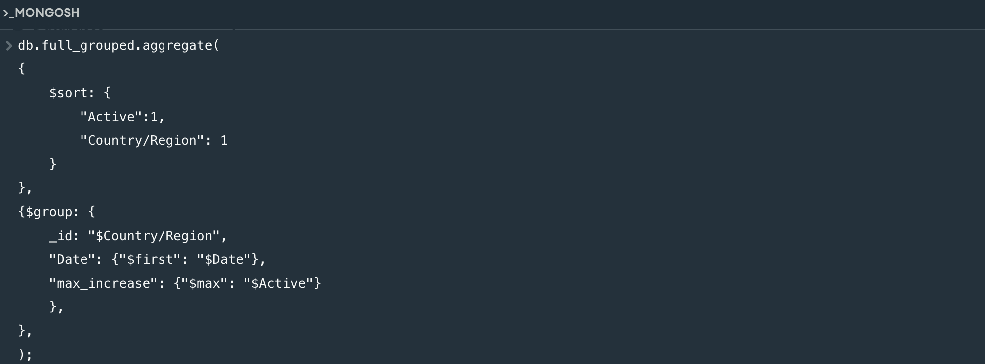

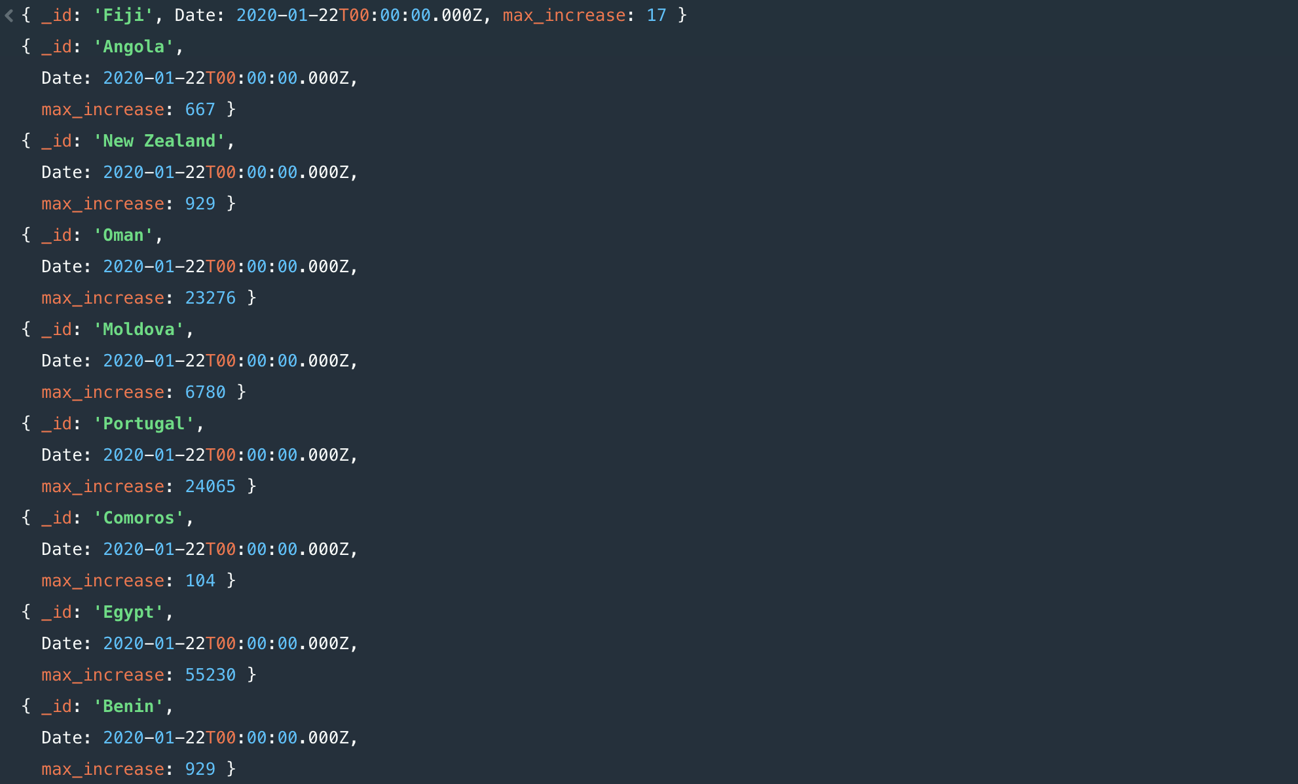

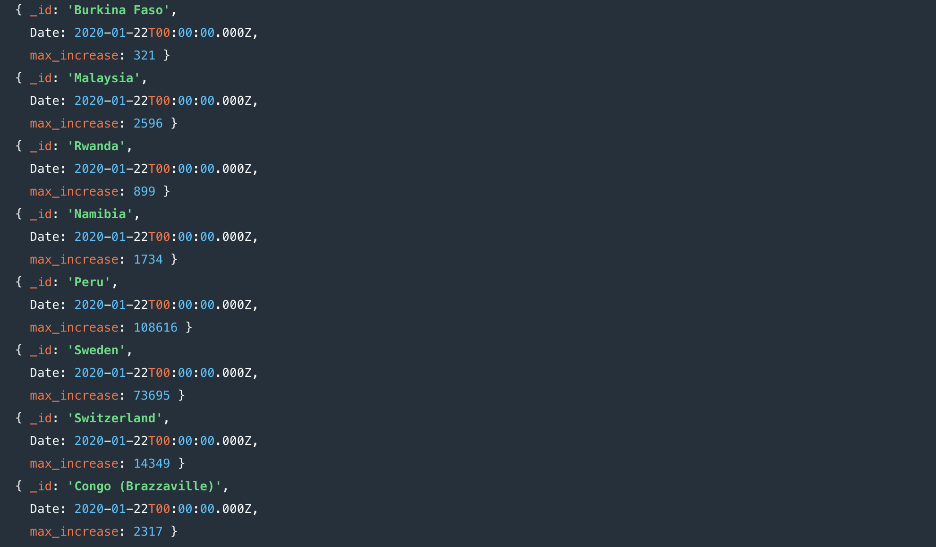

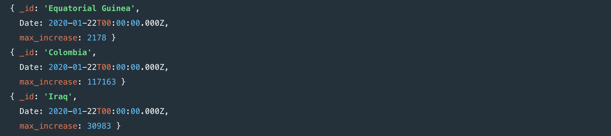

-x-x Thank You -x-x